**CS Project**

# **Introduction:**

Encryption is used in everything in the Morden world from most websites with HTTPS and WhatsApp to bank transfers. Therefore, it is incredibly important people understand the basics of how encryption works and how secure different types of encryption are. To do this I have created an application to demonstrate how different types of encryption work.

While researching encryption methods i settled on a few that give a wide range of security and difficulty of encryption. These are:

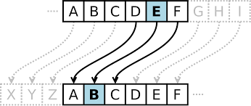Caesar cypher, Being one of the first know created cypher this demonstrates one of the easier encryption methods to use as it works by shifting the letters of the alphabet by a known amount.

Figure - Caesar cypher

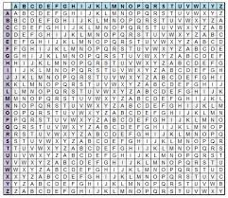

Figure - Vigenère Grid

Vigenère cypher, this is a cypher based of the Caesar cypher. However this cypher increases security greatly by shifting with a key instead of a pre-defined amount. The cypher works using the Vigenère grid (Fig 2). You start by laying your message out with you key beneath it. Then you take the first letters of both putting the key on the Y – axis of the graph and the sentence to be encoded on the X – axis and then find where they intersect getting your encoded character. This cypher demonstrates increased security from using a key instead of a shift method.

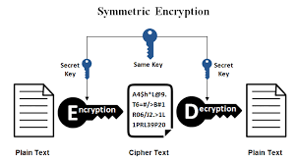

Symmetrical key, this is one of the most commonly used encryption methods used today as it provided some of the best security. This is going to be used to demonstrate how encryption works within the internet today.

Figure - Symmetric key Encryption

# **Design:**

UI design:

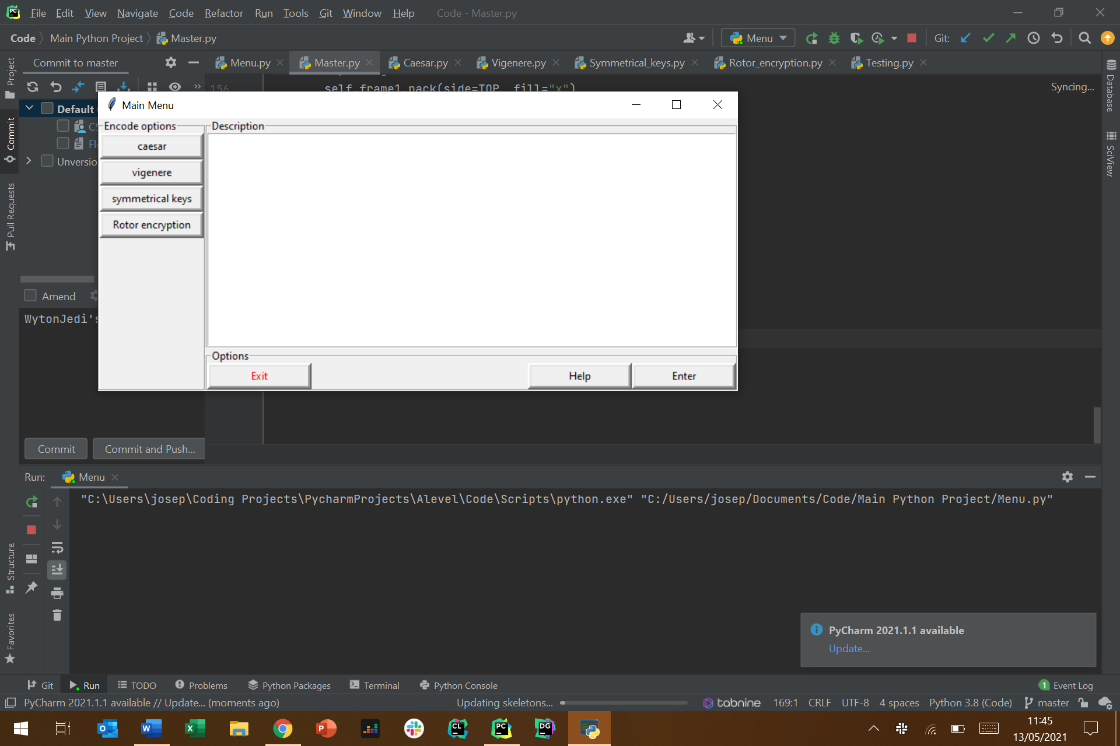

Figure - Main menu UI Design

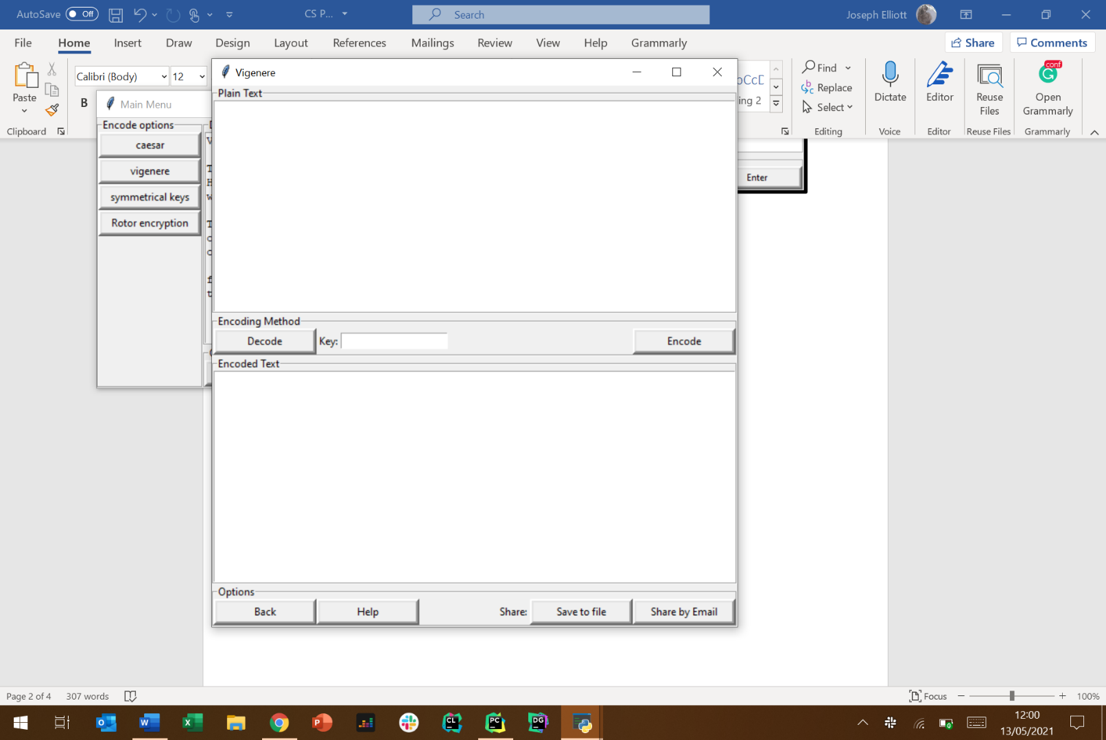

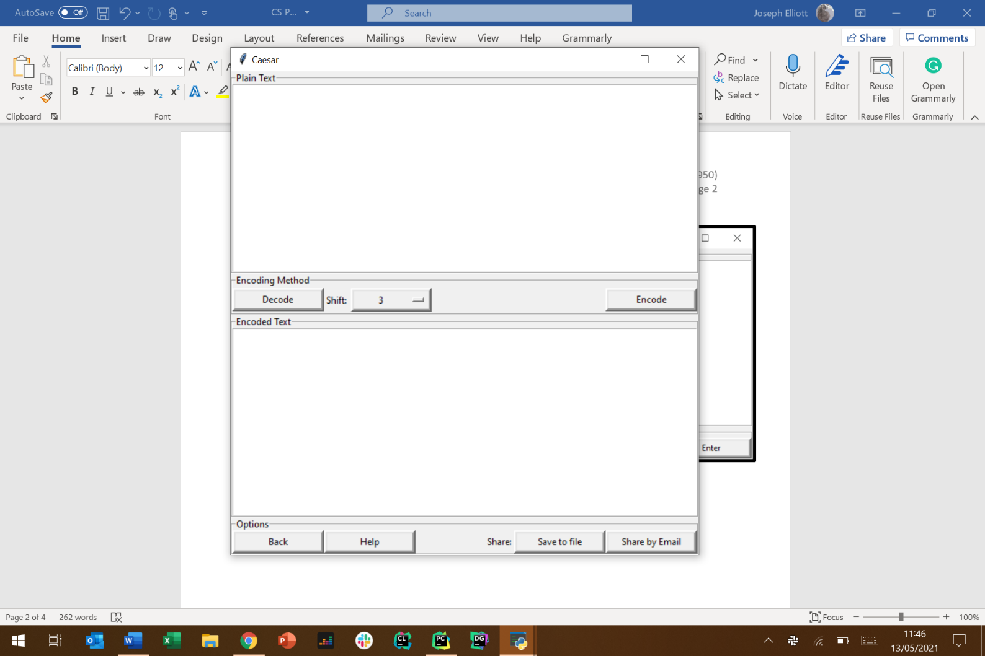

Figure – Vigenère cypher UI Design

Figure - Caesar cypher UI Design

High level Flowcharts:

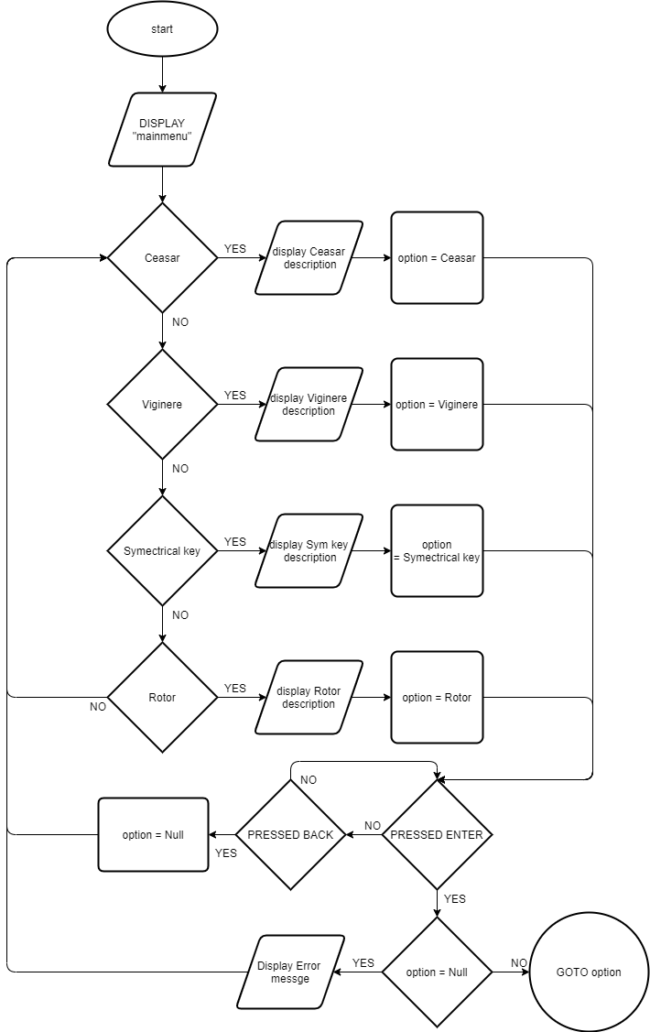

Figure 7 - High Level Flowchart of Main menu UI

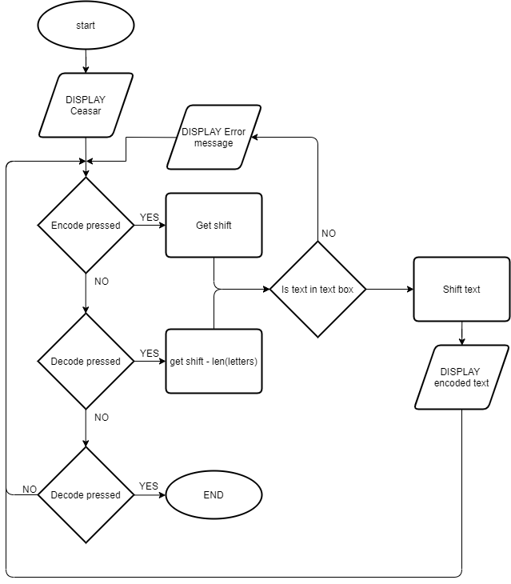

Figure - High level Flowchart of Caesar UI